Mark Freeman
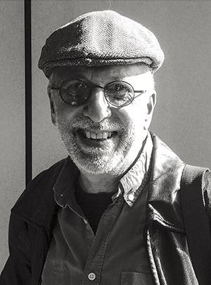

Professor
School of Theatre, Television, and Film
San Diego State University
5500 Campanile Dr
San Diego, CA, 92182
Office: LT 171C
mfreeman@sdsu.edu
https://mfreeman.sdsu.edu/
I make films and teach filmmaking because I believe that motion pictures profoundly shape our attitudes, values and behavior. The images that we create and consume have real power. I am part of a community of filmmakers who act from a belief that the work we do can make a difference.
Documentary filmmaking is about telling stories. The stories I choose to tell are grounded in the experiences of ordinary people. Many of my films are community portraits. Each of my documentaries captures a moment in our shared social history, a fragment of our collective memory in a time of complex challenges and rapid change.
My career as a documentary filmmaker and teacher spans more than 40 years. I’ve created programs that bring grassroots concerns to larger audiences. Mad River: Hard Times in Humboldt County is about timber workers in California’s redwood forests. The Yidishe Gauchos is the story of immigrants from Eastern Europe making new lives on the Argentine pampas. Adobe architecture in New Mexico is the focus of Down to Earth. Indigenous artisans in the Ecuadorian Andes today are literally Weaving the Future.
Since coming to San Diego County, I’ve created a series of portraits of people who make a real difference in the life of their community. Edmund’s Island is a portrait of a homeless news hawker—an angel to his customers. Families and Flowers is the story of growers whose nurseries (and way-of-life) are shadowed by their neighbors’ million dollar homes. In Lines in the Sand tidal artist Kirk Van Allyn etches a sacred space with only ephemeral sand drawings. Talking Peace is a portrait of Jews and Palestinians who are personally engaged in dialogue and peacemaking efforts in San Diego.
For the last few years I’ve reconnected with the performing arts. (I am a graduate of the San Francisco Art Institute.) Poetry Live(s) features of the work of up-and-coming slam artists. Trolley Dances are site-specific performances along the San Diego trolley routes. Queens Dream is a dance for camera performed at Niki de St. Phalle’s Queen Califia’s Magical Circle, a sculpture garden in Escondido.
I’ve spent a major part of my career working as an independent documentary filmmaker. On most of my productions I am the producer, director, writer, videographer and editor. I raise the funds, research the material, create the personal connections, shoot, record, structure and edit these films.
Working independently in the U.S. and overseas has shaped my vision. I bring an international perspective to my work and to my teaching. Productions and other professional opportunities have brought me to Mexico, Guatemala, Argentina, Ecuador, Costa Rica, Cuba, China and Israel. Fulbright Fellowships have taken me to Indonesia and South Africa. I created a series of dance documentaries and site-specific dance films there, as well as a short dance film shot in Ghana. The American Film Showcase has tapped me as an “envoy” to Ukraine and Kyrgyzstan.
My work has aired widely, including PBS, the Museum of Modern Art (NY), and the Smithsonian Institute’s National Museum of Natural History (Washington, D.C.). They have won numerous awards and international recognition at festivals, and are in the collection of libraries and universities throughout the country.
Faculty Main Page

